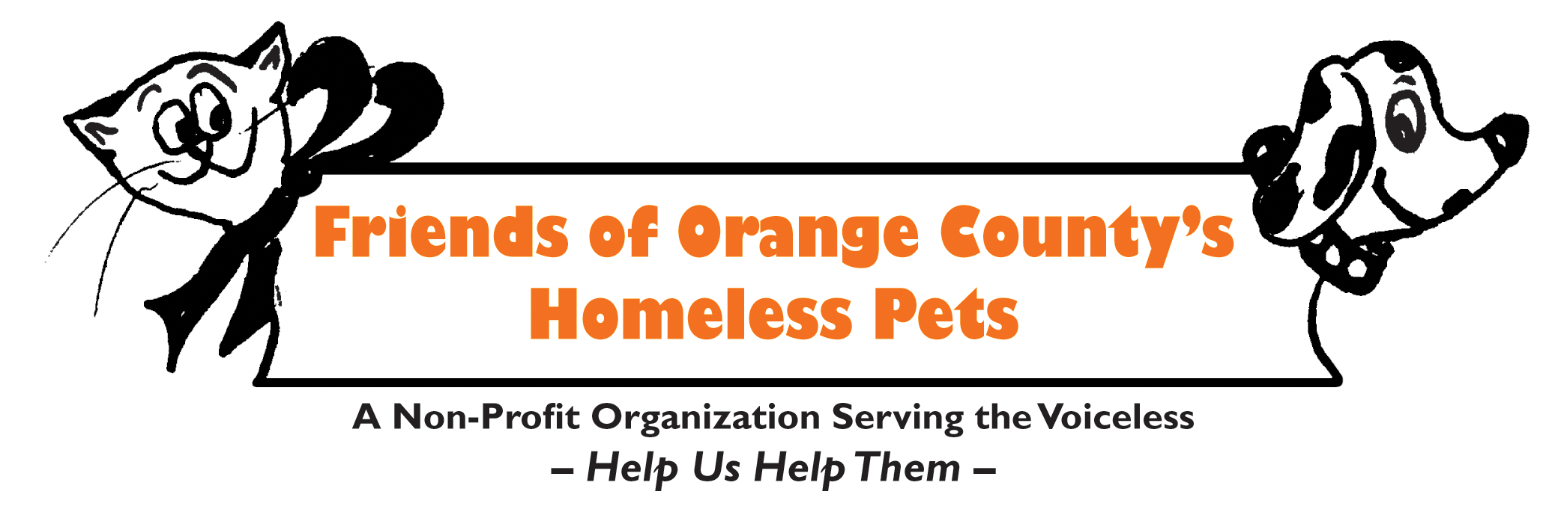

Early Adoption Release Contract/Waiver

I am adopting a Kitten from (FOCHP)

Friends of Orange County’s Homeless Pets. I understand it is policy that all of their animals be

spayed or neutered before going to their new home. Due to special circumstances, I will be allowed

to take this pet home today with the understanding that he/she will be spayed/neutered by the date

listed below.

If for any reason I am unable to keep this pet I will return to FOCHP. I will not give this pet away to anyone other than FOCHP. Initial here ________________________

If I do not have this pet spay/neutered, FOCHP has the legal right to take him/her back.

This agreement will take place as below and be effective once adoption fee is received.

FOCHP will schedule an appointment at our vet in Irvine, Fullerton, Menifee or Garden Grove when your kitten is 5-6 months old. You are responsible for any necessary vaccinations in the meantime. We will contact you to arrange a date that is convenient for you – you will drop off and pick up same day at our vet– FOCHP will be responsible for all spay/neuter expenses on this day. You must go to our vet only. You cannot change any terms of this contract. You cannot elect to go to your own vet and you cannot elect NOT to have this kitten spayed/neutered. This kitten has received the first vaccination and been microchipped as well as first deworming.

Date of Adoption _______________________________ Species _____ cat__

Kitten Name:______________________________________________________

** I have read the following paper and understand the early-release policy. ___________ initial

Name of Adopter ________________________ Signature of Adopter ________________________________

Address_________________________________________________________Phone #_____________________

Email address: _______________________________________________________________________________

Signature of FOCHP Representative __________________________________________________

